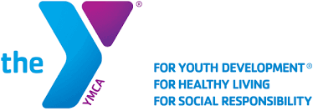
Facility Hours
Monday-Friday 5:30am-9:00pm
Saturday 9:00am-6:00pm
Sunday 2:00pm-6:00pm
Newberry County Family YMCA
8220 Jollystreet Road
Newberry, SC 29108
803-276-9936
MONDAY | TUESDAY | WEDNESDAY | THURSDAY | FRIDAY | SATURDAY
Total Body Strength  6am  Weight Room  Kurt | Bootcamp  6am-7am  Kurt | Total Body Strength  6am  Weight Room  Kurt | Spin  6am-7am  Kurt | Total Body Strength  6am  Weight Room  Kurt
Calorie Burn 8am-9am  Amber | Spin and  Tone  8am-9am | Calorie Burn  8am-9am  Amber | Spin and Tone  8am-9am  Rhonda | Bootcamp 8am-9am  Amber
Zumba  9am-10am  Amber | Step  9am-10am  Amber | Zumba  9am-10am  Amber |  | Zumba  9am-10am  Amber | Cycle  9:15am  Kurt
Yoga  10am-11am  Cynthia | Silver  Sneakers  10am-11am  Norma/Judy | Yoga  10am-11am  Cynthia | Silver Sneakers 10am-11am  Norma/Judy |  | Yoga  10am-11am  Kelly
Water Aerobics  10am-11am |  | Water Aerobics  10am-11am |  | Water Aerobics 10am-11am | Water Aerobics 10am-11am
Pickleball  10am-12pm |  | Pickleball  10am-12pm |  | Pickleball  10am-12pm | Pickleball  9am-11am
Breathe and Stretch  11:30am  Cynthia | Building Community, One Class at a Time
Total Body Strength  4:45pm-5:45pm  YMCA360 | Calorie Burn  4:45pm-  5:45pm  YMCA360 | Total Body Strength  4:45pm-5:30pm  Kurt | Calorie Burn 4:45pm-5:30pm  Kurt | 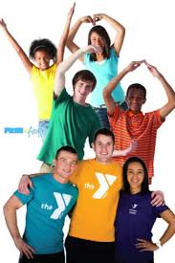
Yoga
5:45pm-6:45pm
Kelly
Cycle  5:45pm-6:45pm  Kurt | Barre  5:45pm-6:30pm  Kurt | Cycle  5:45pm-6:45pm  Kurt | Barre  5:45pm-6:30pm  Kurt
 | Water Aerobics 6:45pm  Kurt |  | Water Aerobics 6:45pm  Kurt
Group Exercise Class Pool Exercise Class Basketball Court
Class Descriptions
Barre – Low intensity ballet inspired workout using a combination of ballet, yoga, Pilates and strength exercises.
Bootcamp – High intensity interval based full body workout combining body weight, cardio, and strength exercises.
Breathe & Stretch – Gentle chair based yoga including seated and standing poses.
Calorie Burn – High intensity full body cardio and strength workout combining weight exercise exercises and the use of strength equipment.
Cycle – High intensity cardio workout using stationary bike.
Pickleball – Game resembling tennis in which players use paddles to hit a perforated plastic ball over a net.
Silver Sneakers – Low intensity chair based strength exercise class using hand weights, resistance bands, and various other equipment.
Spin and Tone – Combination of cycle and full body toning exercises using body weight and hand weights.
Step – Aerobic cardio workout using a step for entire workout.
Total Body Strength – High intensity workout involving intervals of both cardio and strength exercises.
Water Aerobics – Aerobic exercise while in the water
Yoga – Suitable for all levels, focuses on increasing balance and flexibility through bodily posture and breathing exercises.
Zumba – Low to high intensity Latin inspired line dance class.
Introducing YMCA360
YMCA360 is an on-demand video platform for our Y community. YMCA360 offers group exercise classes, youth sports training, well-being classes and more to serve you wherever you are. Whether you are at home or on the road, take the Y with you along with your favorite classes, instructors and more. Ask Member Services for more details.
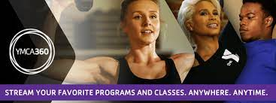
YMCA Mission: To put Christian principles into practice through programs that promote healthy Spirit, Mind, and Body for All.

